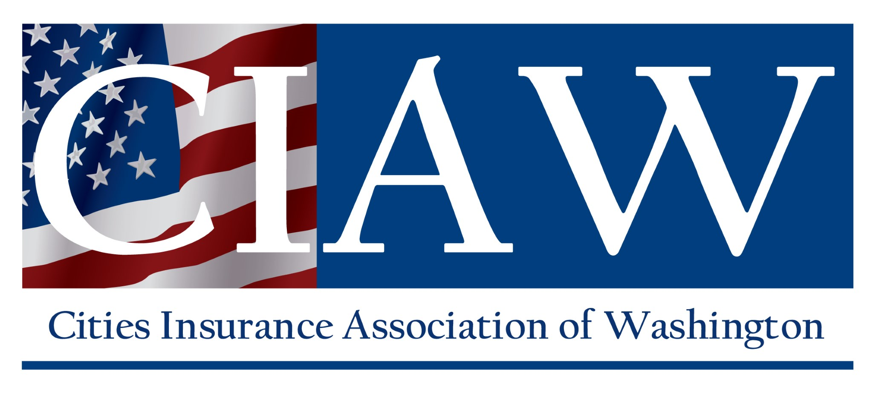 | Inflatable Structures Supplemental Application | 451 Diamond Drive  Ephrata, WA 98823  Tel.: 509-754-2027 or  800-407-2027  Fax: 509-754 3406 slyon@chooseclear.com
ENTITY INFORMATION
Please work with your broker, if applicable, to complete the application below for any inflatable structure that has a platform, floor, or other artificial surface on which users stand, slide, etc. and/or any inflatable structure to which users are tethered or otherwise attached. Please submit the completed application and requested documents at least one week prior to your event.
Member:
What type(s) of inflatable structure(s) will you be using (ex: bouncy house, obstacle course, waterslide, etc)?
For what purpose will the inflatable structure(s) be used (ex: fundraiser, holiday event, field day, etc)?
Please submit the following documents for review (please note that entity-owned inflatable structures are not eligible for liability coverage):
Copy of the vendor contract. Contract must include:
- Language holding the entity harmless. Contract may not hold the vendor harmless.
- Vendor must name the entity as Additional Insured.
- Vendor must carry Commercial General Liability limits of at least $3,000,000 per occurrence and $5,000,000 aggregate.
- Vendor is required to set up the equipment and remain onsite to supervise the inflatable structure(s) for the duration of the event.
- At least one employee of the vendor must be designated to determine if conditions become too dangerous for the safe operation of the inflatable structure (ex: weather conditions become too windy or rainy), and this individual must remain onsite at all times.
- When signed on behalf of the entity, the signature must be that of the entity risk manager or entity official.
Copy of the vendor’s written plan for the safe operation of the inflatable structure, including maximum loads and number of
participants at any one time, age and weight limits, anchor requirements, minimum clearance around each inflatable structure,
and a policy to prohibit small and large children from using the device at the same time.
Photo(s) of the inflatable structure(s) to be used.
If coverage is approved, a copy of the Certificate of Insurance with additional insured endorsement from the vendor must be
submitted to our office prior to your event.
Please include any additional information that may be useful here:

The above and any supplemental information is prepared and submitted on behalf of the member for coverage consideration. The receipt of application information does not constitute an obligation or commitment on the part of the Cities Insurance Association of Washington or its representatives to provide coverage protection. I certify that the information within this application and any supplemental information is true and accurate.

AUTHORIZED REPRESENTATIVE (Entity Risk Manager or Entity Official Only):
Name Title

Signature Date

Please send completed applications to Stacy Lyon at slyon@chooseclear.com
3/17/2022 Page 1 of 1

